Summer School Schedule Location: Teaching Building 2, Room 201（教二楼201）

 | 8/12 | 8/13 | 8/14 | 8/15 | 8/16
9:00-10:30 | Practicalities  John Moore | Governance  Andy Parker | Extremes  Helene Muri  John Moore | GeoMIP  talks | GeoMIP  discussions
Break | Coffee/tea | Coffee/tea | Coffee/tea | Coffee/tea | Coffee/tea
11:00-12:30 | Introduction to GeoMIP and GLENS  Simone Tilmes | Marine Cloud Brightening  Helene Muri | Impact models  John Moore | GeoMIP  talks | GeoMIP  discussions
 | Lunch | Lunch | Lunch | Lunch | Lunch
14:00-15:30 | Economics  Masa Sugiyama | Emulation  Ben Kravitz | Open topics and student discussions | GeoMIP  talks | GeoMIP  discussions
Break | Coffee/tea | Coffee/tea | Coffee/tea | Coffee/tea | Coffee/tea
16:00-17:30 | Python for geoengineering  Duoying Ji | GeoMIP and Downscaling  Duoying Ji  John Moore | GeoMIP  talks | Poster Session | Great Debate  Alan Robock  Andy Parker  Mike Wolovick  Peter Irvine  Simone Tilmes
 |  |  |  | GeoMIP/summer school dinner

GeoMIP9 agenda

Talks are 12-15 minutes with 5-8 minutes for questions/answers.
All poster presenters should bring their posters as powerpoint slides. They will have two minutes each during the poster introductions session to talk about their posters.
Please note: University WiFi will not be available.

Wednesday 14 August
Location: Teaching Building 2, Room 201（教二楼201）

16:00-16:10 Opening/welcome remarks John Moore

16:10-16:30 Comparison of SO₂ and H₂SO₄ injection strategies using Daniele Visioni
a modal aerosol microphysics representation in CESM2
16:30-16:50 First results of the H₂SO₄ injection experiments Ulrike Niemeier
16:50-17:10 Impacts of Sulfate Injection Geoengineering on Particulate Alan Robock
Matter with Diameter less than 2.5 µm
17:10-17:30 Impact of Geoengineering on Human Health from Urban Liyi Chen
Heat Stress

Thursday 15 August
Location: Teaching Building 2, Room 201（教二楼201）

9:00-9:20 Impact of solar radiation modification in a fully coupled Izidine Pinto
CESM1 over Southern Africa
9:20-9:40 A new multi-model stratospheric heating experiment and Peter Irvine
a general analysis framework for evaluating solar
geoengineering performance
9:40-10:00 Greenland ice sheet response to stratospheric aerosol Yue Chao
injection geoengineering
10:00-10:20 Mitigation of circum-Arctic permafrost carbon loss Yating Chen
through stratospheric aerosol geoengineering

10:20-11:00 Discussion and break

11:00-11:20 Review of the treatments of solar geoengineering in the Masa Sugiyama
IPCC reports
11:20-11:40 Paris is burning: quantifying limits to mitigation and Andrew Lockley
Carbon Dioxide Removal (CDR) - implications for Solar
Radiation Management (SRM), and technological and
societal change
11:40-12:00 Climate modeling Marine Cloud Brightening scenarios: Rob Wood
work in progress and a proposal for future GeoMIP
activities
12:00-12:20 Reaching 1.5C and 2.0C global surface temperature Simone Tilmes
targets using stratospheric aerosol geoengineering based
on two CMIP6 future pathways
12:20-12:40 Targeted glacial geoengineering Michael Wolovick

12:40-14:00 Lunch

14:00-14:30 Poster Introductions

14:30-17:30 Poster session (with coffee) + discussions/free time

17:30- Group dinner

Friday 16 August
Location: Teaching Building 2, Room 201（教二楼201）

Discussion topics
- Results presented/themes that arise during the meeting
- GeoMIP6 simulation status
- Next meeting (GRC) and the one after that
- Papers
- Overshoot scenario
- DECIMALS

9-10:30 Discussion
11:00-12:30 Discussion

12:30-14:00 Lunch

14:00-15:30 Discussion, adjournment

16:00-17:30 Great Debate (public event)

Saturday 17 August
Location: Jingshi Science and Technology Buiding, Block B, Room 518 （北师大南苑，京师科技大厦B座518）.

Private meetings scheduled.

Poster presentations

- Ilona Mettiäinen – TBD
- Heri Kuswanto - Extreme indices over Indonesia
- Andrew Lockley - Geoengineering in God’s name – A role for religiously-obligated payments in financing climate engineering?
- Andrew Lockley - Social, political and economic preconditions for commencement of
geoengineering: a comparison analysis of societal transformation projects.
- Krishnamohan - Climate System Response to Stratospheric Sulfate Aerosols: Sensitivity to Altitude of Aerosol Layer
- Evelyn Ng’ang’a – TBD
- Hassaan Sipra - Annual analysis of the impacts of GeoMIP-based sulfate aerosol injections (G4) on the climate of Pakistan
- Xiaoran Guo - Dynamic response of Jakobshavn Glacier to Geoengineering
- Ruchi Singh - Impacts of global warming and solar geoengineering on human health over India
- Prasant Bal - Effects of Global Warming and Solar Geoengineering on Precipitation Seasonality
- Mengdie Xie - The impact of Marine cloud brightening Geoengineering on the AMOC
- Peter Irvine - A new multi-model stratospheric heating experiment and a general analysis framework for evaluating solar geoengineering performance

Map of Beijing Normal University:

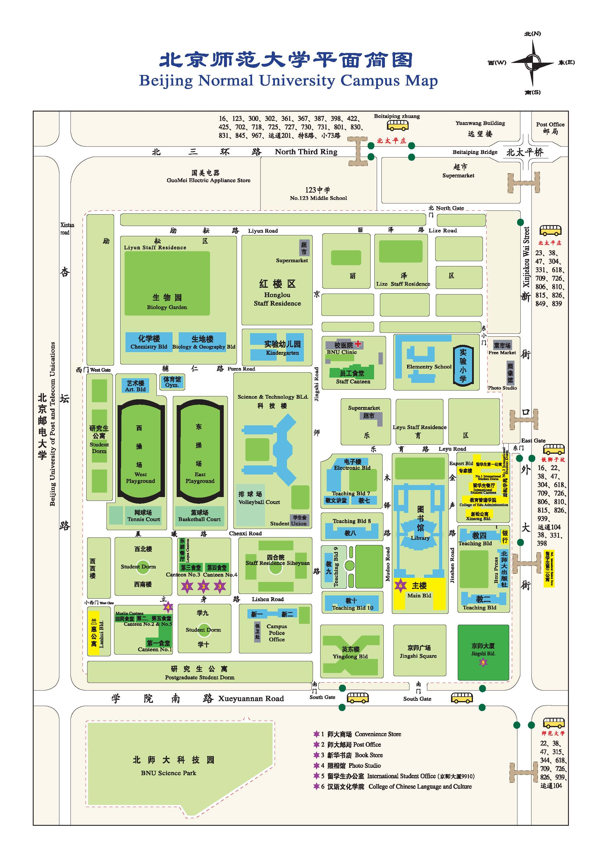
Teaching Bld No.2
Jingshi Hotel

